**Project Report**

**Title of Project:** AI Like Skill Coach  
**Name of the Innovator:** Navaneeth YM  
**Start Date:** 13-10-2025  
**End Date:** 17-10-2025

**Day 1: Empathise & Define**

**Step 1: Understanding the Need**

**Which problem am I trying to solve?**  
I’m solving the problem of limited access to personalized skill development for students and job seekers. Many individuals struggle to improve essential skills like communication, problem-solving, and digital literacy due to lack of guidance, resources, or motivation. My platform offers an AI-powered skill coach that provides tailored learning paths, interactive exercises, and real-time feedback to help users grow effectively.

**Who is affected by this problem?**

* Students in schools and colleges
* Job seekers preparing for interviews
* Professionals aiming to upskill
* Individuals in remote or underserved areas

**How did I find out about this?**

Online Research  
AI Tools

**Step 2: What is the problem?**

The problem is that many learners lack personalized support to build employability and life skills. Traditional learning methods are often generic, inaccessible, or unengaging. Without proper guidance, learners struggle to identify their weaknesses, track progress, and stay motivated.

**Why is this problem important to solve?**  
Solving this problem empowers individuals to become job-ready, confident, and adaptable. It bridges the gap between education and employment by offering personalized, accessible, and engaging skill development support.

**Take-home task: Feedback from 3 people**

1. **Student (College Graduate):**  
   “This AI coach sounds great! I often don’t know which skills I need to improve or how to practice them. If it can guide me and give feedback, it’ll be super helpful.”
2. **Trainer (Soft Skills Coach):**  
   “Many students need personalized coaching but we can’t reach everyone. An AI-based coach can scale this support and make skill-building more consistent.”
3. **Parent (Urban Household):**  
   “I like the idea because it helps our children learn important skills without needing expensive coaching. It’s like having a personal tutor at home.”

**AI Tools Used (Step 1 & 2)**

* **Meta MGX:**  
  Used to build the AI Skill Coach app with no-code tools. Designed interactive modules, user profiles, and feedback systems.
* **ChatGPT:**  
  Helped generate content, design conversation flows, and create personalized learning paths.
* **Chatbot References:**
  + Google Dialogflow
  + IBM Watson Assistant
  + Microsoft Bot Framework

**Day 2: Ideate**

**Step 3: Brainstorming Solutions**

* AI Skill Coach – Personalized guidance and feedback for skill development
* Gamified Learning App – Skill-building through challenges and rewards
* Skill Assessment Portal – Tests and analytics to identify strengths and weaknesses
* Community Learning Circles – Peer-to-peer learning and mentorship
* Mobile App for Daily Skill Tips – Bite-sized lessons and reminders
* AI Like Skill Coach – A complete platform with personalized coaching, interactive modules, and progress tracking

**Step 4: My Favourite Solution**

My favorite solution is **AI Like Skill Coach**, a digital platform that offers personalized skill development through an AI-powered coach. It guides users through tailored learning paths, interactive exercises, and real-time feedback to improve communication, problem-solving, and digital skills.

**Step 5: Why am I choosing this solution?**

It combines personalization, accessibility, and engagement. The AI coach adapts to each user’s needs, making learning more effective and enjoyable. It’s scalable, mobile-friendly, and ideal for students and job seekers.

**AI Tools Used (Step 3–5)**

* **Meta MGX:**  
  Designed the app interface, modules, and feedback system.
* **ChatGPT:**  
  Generated content, structured conversations, and created learning paths.
* **AI Chatbot References:**  
  Dialogflow, IBM Watson Assistant, Microsoft Bot Framework
* **AI Research Tools:**  
  Google Scholar, AI Summarization Tools

**Day 3: Prototype & Test**

**Step 6: Prototype – Building My First Version**

**What will my solution look like?**

* **Home Screen:** Welcomes users, collects basic info (age, goals, skill level)
* **AI Skill Coach:** Chat interface for personalized guidance and feedback
* **Skill Modules:** Interactive lessons on communication, problem-solving, digital literacy
* **Progress Tracker:** Visual dashboard showing completed modules and skill growth
* **Daily Challenges:** Engaging tasks to reinforce learning

**Design Style:**  
Simple, engaging, mobile-friendly, and intuitive for all users

**Prototype Tools:**  
Built using Meta MGX with interactive features and no coding required

**AI Tools Needed to Build This**

* **Meta MGX:**  
  No-code platform for building the app and modules
* **ChatGPT:**  
  Content generation, conversation design, and feedback logic
* **AI Chatbot Design References:**  
  Dialogflow, IBM Watson Assistant, Microsoft Bot Framework

**Final AI Tools Selected**

* **ChatGPT**
* **Meta MGX**

**Tool Link:** <https://mgx-xfl7131ilto.mgx.world/>

**Application Dashboard**

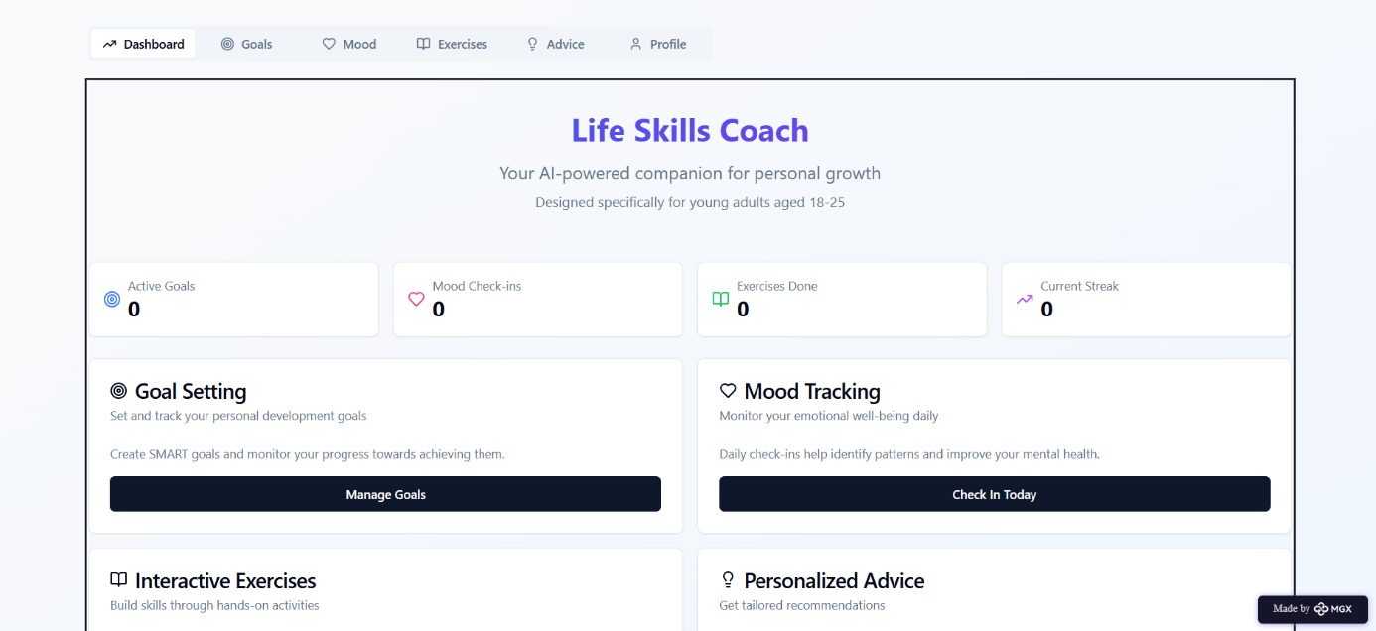

**

**Mood & Wellness Tracker**

**Goal Tracker**

**Exercise Hub**

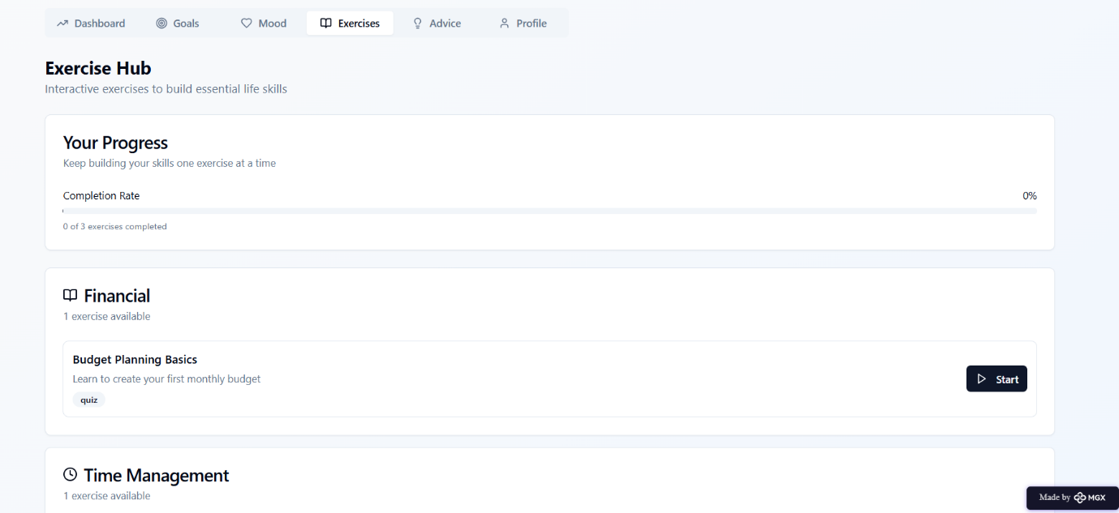

**Personal Advice**

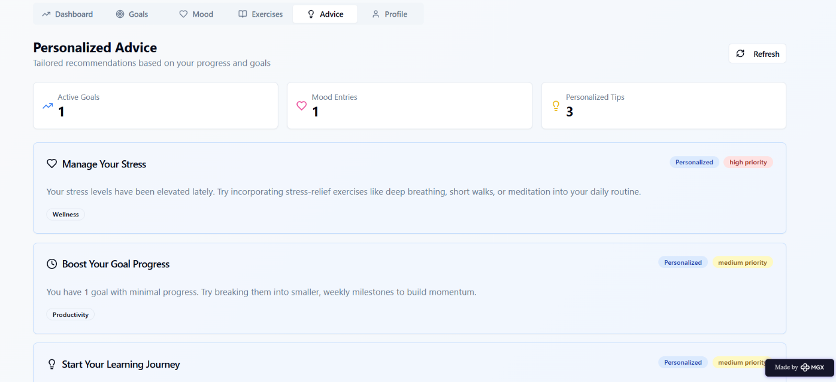

**GitHub Repo:** <https://github.com/Navaneethym/Life-skill-coach--No-code-application/upload>

**Step 7: Test – Getting Feedback**

**Who did I share my solution with?**

* Students
* Trainers
* Parents
* Peers and mentors

**Feedback: Pros and Cons**

**Pros:**

* Personalized guidance appreciated
* Interactive modules engaging
* Easy to use and accessible

**Cons:**

* Some feedback responses were repetitive
* Limited content in prototype
* Needs more integrations for advanced features

**My Response:**  
The current version is a prototype built using Meta MGX. Full functionality will require partnerships and more resources. The concept shows strong potential and usability.

**What Works Well**

* Lifetime Access
* No-Code Development
* Personalized Guidance
* Skill Building Modules
* Mobile-Friendly Interface

**What Needs Improvement**

* Chatbot Response Variety
* Feature Accessibility
* Resource Integration
* Collaborations for Expansion
* Enhanced User Experience

**AI Tools for Step 6–7**

* ChatGPT
* Meta MGX

**Day 4: Showcase**

**Step 8: Presenting My Innovation**

I am presenting **AI Like Skill Coach**, a digital skill development platform featuring:

* AI-powered coach for personalized guidance
* Interactive modules for essential skills
* Progress tracking and daily challenges
* Built using Meta MGX with lifetime access

**Impact:**  
Empowers learners to build employability skills, boosts confidence, and bridges the skill gap.

**Step 9: Reflections**

**What did I enjoy the most?**  
Designing the AI coach and seeing my idea come to life through a no-code platform.

**What was my biggest challenge?**  
Integrating feedback and skill modules smoothly with limited resources.